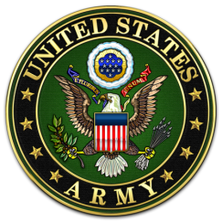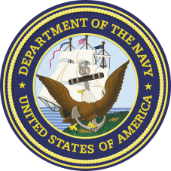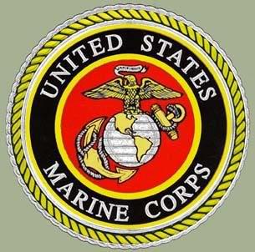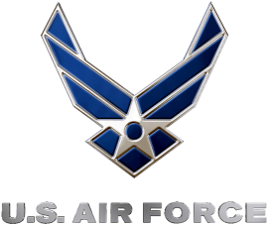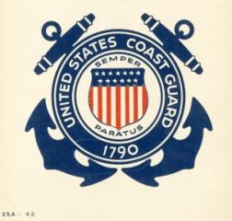
Interview a Veteran Assignment
Interview a family member, friend, or neighbor that has served in the US Armed Forces. Write your veteran’s answers in the spaces provided below. Interview will be due Tuesday, November 13th.
Type your personalized interview and print your interview.

- Which branch of the Armed Forces did you serve?

- Why did you join and why did you select that branch to serve in?

- What was boot camp/basic training like? Provide a memory or describe what a typical day might look like?

- When did you serve? For how long?

- Did you serve during any wars or conflicts? If so, which ones? What was it like?

- What is one of your favorite memories?

- Were you awarded any medals or citations/promotions? If so, which ones? Why did you earn these?

- How did your service in the military affect your post-active duty civilian life?

Make sure to thank your veteran for taking the time to answer your questions, and more importantly thank them for their service to our country.

