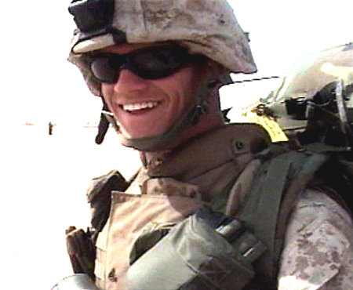
Jason L. Dunham
Born: 10 November 1981 in Scio, New York
Served: 2000 - 2004
Rank: Corporal
Unit: 3rd Battalion, 7th Marine Regiment, 1st Marine Division
Branch: U.S. Marine Corps
Corporal Jason Dunham was posthumously awarded the Medal of Honor on January 11, 2007—the first Marine to receive the honor since Vietnam—for conduct above and beyond the call of duty. Dunham joined the Marine Corps in 2000, and by 2004 was assigned to 4th Platoon of K Company in Iraq. On April 14, 2004 his platoon was operating a checkpoint near the Syrian border when the call came in that an American convoy in their vicinity was under fire. As Dunham’s platoon raced to provide reinforcements, they came upon a column of suspicious looking Iraqi vehicles. The Americans began to search the vehicles for weapons.
One of Dunham’s men found a rifle stuffed under a floormat. Before the Americans could react, the driver of the vehicle jumped out and grabbed Dunham by the throat. As the two wrestled, the Iraqi dropped a live grenade on the ground. Surrounded by at least two squad members, Dunham dived on the grenade to shield his friends from the blast. He saved their lives, but was grievously injured. He had covered the grenade with his Kevlar helmet in an attempt to stem the explosion. His helmet had splintered under the pressure, sending Kevlar pieces into his torso and skull. Dunham survived long enough to be evacuated to Bethesda Naval Hospital, but he slipped into a coma and was taken off life-support eight days after the attack.
In a previous conversation with some buddies, Dunham had talked about the best way to absorb the blast of a grenade. While one Marine postulated that they could use their forearms to pin the grenade beneath their Kevlar chest piece, losing their arms but saving their life, Dunham suggested instead using a Kevlar helmet to isolate the grenade. Dunham backed up his words with stoic action that day, saving the lives of his brothers. He was a true hero according to his friends, a Marine’s Marine.
In July 2009, Dunham’s helmet was put on display at the National Museum of the Marine Corps. One piece of the helmet was sealed in the hull of a Navy Destroyer named in his honor.

