John Basilone - The Pacific - Medal of Honor Recipient
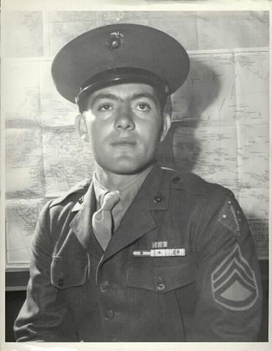
John Basilone (born on November 4, 1916) was the sixth of Salvatore and Dora Basilone's ten children. Born in Buffalo, John moved with his family to Raritan, New Jersey, where his father ran a tailor shop. The family lived at 113 First Avenue.
In 1917, when Johnny was just a baby, he posed for a portrait with his siblings.
Growing up in Raritan, Johnny was a student at St. Bernard's parochial school, but he didn't really like it. Deciding not to attend high school, he joined the Army in 1934.
Serving much of his three-year enlistment in the Philippines - with Company D, 16th Infantry - John also became a light-heavyweight boxer. (He was undefeated in nineteen bouts.) Because he talked so much about his Philippine experiences, he earned the nickname "Manila John."
After his honorable discharge, as a Private First Class, John returned to Raritan where he drove a truck for Gaburo's Laundry. He also caddied at a local golf course.
In July of 1940, while war was raging in Europe but before Japan attacked Pearl Harbor, John joined the Marines. At some point in his military career, he decided to get a tattoo on his left arm. Featuring a sword, the design included these words: "Death before Dishonor."
In 1942, during the Battle of Guadalcanal, John Basilone demonstrated extraordinary bravery (as described in Strong Men Armed, a book by Robert Leckie) during the night of October 24th. He won a Medal of Honor for his actions, and his Citation notes the specifics:
While the enemy was hammering at the Marine's defensive positions, Sgt. Basilone . . . fought valiantly to check the savage and determined assault. In a fierce frontal attack with the Japanese blasting his guns with grenade and mortar fire, one of [his] sections with its guncrews, was put out of action, leaving only two men to carry on.
Moving an extra gun into position, he placed it in action, then, under continual fire, repaired another and personally manned it, gallantly holding his line until reinforcements arrived.
A little later, with ammunition critically low and supply lines cut off, Sgt. Basilone, at great risk of his life and in the face of continued enemy attack, battled his way through the hostile lines with urgently needed shells for his gunners, contributing . . . to the virtual annihilation of a Japanese regiment.
With his Medal of Honor, Basilone was sent back to the States to help raise money during the Third War Loan Drive. Although he disliked most of the fuss which people made over him, he did enjoy a huge gathering in his hometown. Life reported that event with words and pictures:
After he had been greeted by most of the important people in Somerset County, he went to mass at St. Ann's Church with his family. There was a big luncheon in his honor, and after that a parade in which marched soldiers and Wacs from Camp Kilmer.
A dirigible flew overhead, bands played, and 15,000 people lined the streets to see him go by. A crowd of almost 30,000 gathered at the Doris Duke Cromwell estate for food and speeches. Later there was a big bond rally at which war trophies were auctioned. Pledges of $1,400,000 were made, and the community presented John with a $5,000 bond for himself.
Using language of the times, Life's reporter describes the event which had catapulted Basilone into America's national consciousness:
He was platoon sergeant of a battalion guarding Henderson Field [on Guadalcanal], in charge of four heavy machine guns. One by one the men were wounded, and he took over two guns, firing first one and then rolling over on the ground to fire the other. When ammunition got low he ran 150 yards through the Jap lines to bring back more rounds. Every now and then he'd use his pistol to pick off a Jap at close range. By 5 o'clock in the morning the enemy dead were piled high around the guns. (Life, 11 October 1943, page 127.)
John Basilone, Medal of Honor winner (for Guadalcanal) and posthumous recipient of the Navy Cross (for Iwo Jima), was the only enlisted man to receive both honors. He also received a Purple Heart.
Not long before Basilone and his fellow Marines shipped-out to Iwo Jima, he married Lena Riggi (another Marine). She survived him by 54 years - and never married again.

