Hall of Heroes: Honoring Specialist Ross A. McGinnis

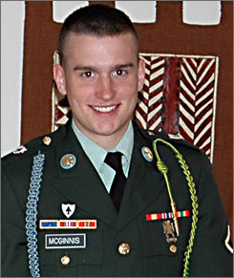
Ross A. McGinnis
Born: 14 June 1987 in Meadville, Pennsylvania
Served: 2004 - 2006
Rank: Specialist
Unit: 26th Infantry Regiment, 2nd Brigade Combat Team, 1st Infantry Division
Branch: U.S. Army
Specialist Ross McGinnis lived to serve in the United States Army. Born in Pennsylvania, McGinnis was an engaging personality, helping those around him as a member of Boy Scouts. He felt a call to serve early in his life. When his Kindergarten teacher prompted his class to draw what they wanted to be when they grew up, McGinnis drew a soldier. He enlisted in the Army as soon as he could through the delayed entry program, on his 17th birthday in 2004.
After training at Fort Benning in Georgia, McGinnis was deployed with the 1st Battalion, 26th Infantry Regiment to Eastern Baghdad. The capital of Iraq was a treacherous assignment; it was before the surge, and the violence was endemic.
McGinnis was part of a mobile patrol on December 4, 2006. As part of 1st Platoon, C Company, he served as the machine gunner for the M2 .50 cal in the Humvee bringing up the rear of the patrol. As the unit moved through a particularly dangerous section of the city, an insurgent hidden on a rooftop threw a grenade at the convoy as it drove by. As the last vehicle in the line, McGinnis’s Humvee was hit.
The grenade fell into the turret hole where McGinnis was keeping watch. He acted without hesitation, calling out ‘Grenade!’ to alert his four comrades in the vehicle beneath him. McGinnis could have easily escaped from the blast by jumping out of the turret position and onto the roof of the truck, but he chose not to. He decided that the lives of his fellows were more valuable than his own life. He fell onto the grenade, absorbing the blast and sheltering the four men in the Humvee. Specialist McGinnis died in the explosion, but his act saved the lives of his friends. All of them walked away from the attack without serious injury. McGinnis was only 19 years old when he sacrificed himself on the streets of Baghdad.
On June 2, 2008, President Bush presented his parents Thomas and Romayne McGinnis with the Medal of Honor posthumously. McGinnis was the fourth American to be awarded the military’s highest distinction.

