[](http://www.myfonts.com/fonts/nicky-laatz/ernest-and-emily/)[](http://www.myfonts.com/fonts/nicky-laatz/ernest-and-emily/caps/) [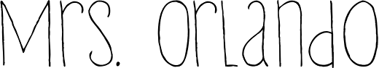](http://www.myfonts.com/fonts/hanoded/lampion/)

[](https://www.myfonts.com/fonts/upir-typo/thinpaw/regular/)[Preview ImagePreview ImagePreview Image](http://www.myfonts.com/fonts/nicky-laatz/ernest-and-emily/)[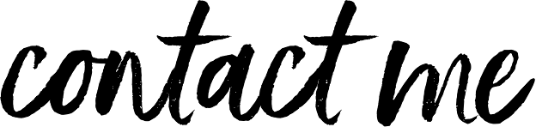](http://www.myfonts.com/fonts/nicky-laatz/ernest-and-emily/regular/)[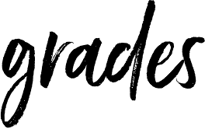](http://www.myfonts.com/fonts/nicky-laatz/ernest-and-emily/)[](https://www.pinterest.com/rache1anne/icons/)

Notebook   
Earbuds / Headphones  
Loose leaf paper  
Pen or Pencil  
Binder / Dividers  
*Colored pencils/markers, scissors, glue sticks used occasionally (will be reminded when needed)

Informal 35%

Formal 65%

[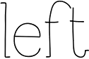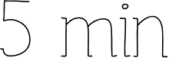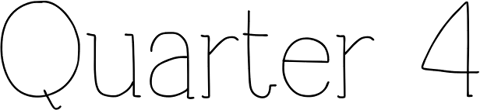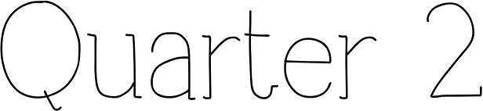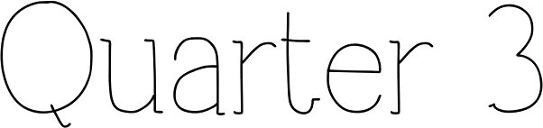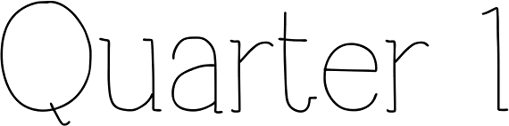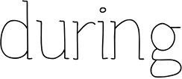](http://www.myfonts.com/fonts/upir-typo/thinpaw/regular/)[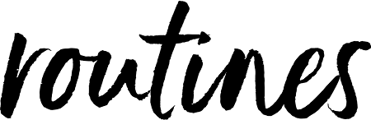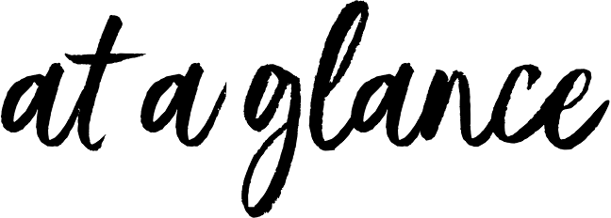](http://www.myfonts.com/fonts/nicky-laatz/ernest-and-emily/solid/)[](http://www.myfonts.com/fonts/nicky-laatz/ernest-and-emily/caps/)

www.amandakorlando.weebly.com  
amandak.orlando@cms.k12.nc.us  
Remind app chat: text 81010  
@orlandored @orlandogre  
@orlandoye @orlandobl

be ready

remain seated

be attentive

be thorough

be a responsible groupmate

clean up after yourself/group

World War II; The Cold War; The Vietnam War; Civil Rights Movement; Searching for Order 1968-2000; The Twenty-First Century

A Divided Nation; The Civil War; Reconstruction; Industrial Revolution; Reform Movements; Immigrants and Urban Life; World War I; The Roaring Twenties; The Great Depression

Forming A Government; Citizenship and the Constitution; Launching the Nation; Early Presidencies; Expansion and Conflict; Slavery in the United States

NC and US Geography, Governments and Economic systems; New Empires in the Americas; American Colonies; The American Revolution

write down your homework

log off Chromebook

turn in assignments

complete exit tickets

stay seated until dismissed

see teacher (by raising hand) for concerns, working lunch passes, etc.

Formal– common assessments, chapter tests, projects  
Informal– quizzes, classwork, homework, participation

have all materials ready

turn in homework

complete bell-work/warmup

login to Chromebook

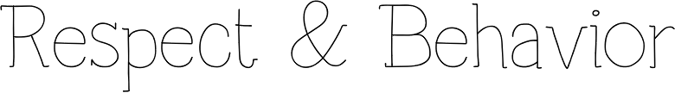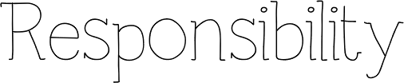

Maintain a respectful and positive attitude toward yourself, your classmates, the teacher, and the classroom. Use common social courtesies: raising your hand, waiting your turn to speak, positively contributing to the learning environment. I have a ZERO tolerance for bullying; disrespectful and/or bullying behavior will result in removal from the class.

Come to class with a positive attitude, with all necessary materials ready, use restroom between classes, clean up after yourself – you will be held accountable for yourself and your learning. Turn in assignments in a timely manner, contact me with any questions.

Students are expected to be prepared for class each day, materials and mindset. Upon entering class, be sure to have your writing utensils ready, Chromebook logged in, homework ready to turn in, and begin warm-up.

[](http://www.myfonts.com/fonts/cultivated-mind/viva-beautiful/)[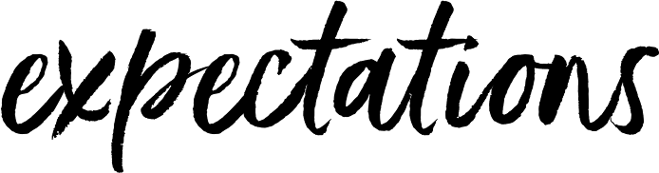](http://www.myfonts.com/fonts/nicky-laatz/ernest-and-emily/solid/)[](http://www.myfonts.com/fonts/nicky-laatz/ernest-and-emily/caps/)

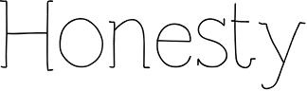

Students are permitted to responsibly use Chromebook for academic purposes only in class. No smartphones or other devices are allowed. Students who abuse these privileges will have them revoked, and an administrator will be notified.

Cheating and plagiarism will not be tolerated in any form. Students caught plagiarizing will be given a Zero for the assignment. Plagiarism includes: turning in someone else’s paper as your own, copying another student’s paper before class (or having another teacher catch you copying work in his/her classroom), failing to cite a source, copying (and pasting) a cite/author’s exact words.  
*\* See Bailey’s Honor Code* *

[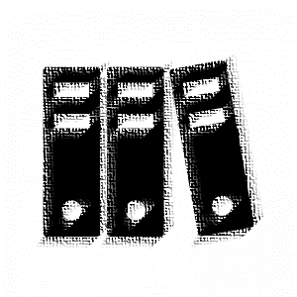](https://www.silhouette-illust.com/illust/15021)[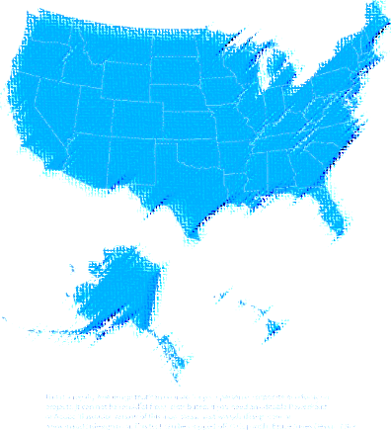](http://www.freerepublic.com/focus/f-chat/3489769/posts)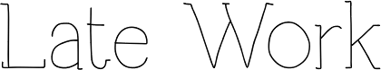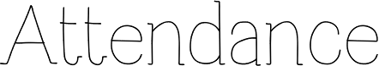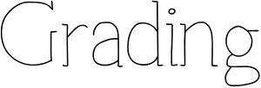

Turn in late work by completing a late work slip and attaching it to the late assignment to-be turned in. Late work will receive no higher than an 80% (Bailey’s Policies). After 2 calendar weeks, the assignment will be marked as a Zero in my gradebook. Late work will be entered at my convenience. Please do not repeatedly ask me to enter it after you turn it in.

* I have read and fully understand the policies and expectations outlined in Mrs. Orlando’s Syllabus. *

Student Signature: ______________________________________ Date: ____________________ Block: _______________

Parent Signature: ______________________________________ Date: ____________________

Attendance and participation are required and have a direct correlation to success to any class. It is your responsibility to find out what work you have missed if absent. Please ask a classmate, refer to my weebly website page, and the “Absent Work” files. Makeup assignments should be submitted in a timely manner (Bailey’s Policies) upon return.

Your parent/guardian must sign the test acknowledging she/he saw your grade. Signed test and completed enrichment review activity must be returned to Mrs. Orlando within 2 days of being passed back in order to be eligible to retake the test/quiz. Retake tests are given at Social Studies working lunch.

Grades will be entered into PowerSchool and updated weekly. Keep all graded work. It is your responsibility to check that your grades match what is entered electronically. If there is a discrepancy, please wait until the end of class (last 5 minutes) or during working lunch to show me the assignment grade in question.